Q1

import org.w3c.dom.ls.LSOutput;  
  
public class Main {  
 public static void main(String[] args) {  
  
 System.*out*.println("3X");  
 System.*out*.println("3X+2y");  
 System.*out*.println("(x+y)/7");  
 System.*out*.println("(3x+y)/(x+2)");  
  
 }  
  
}

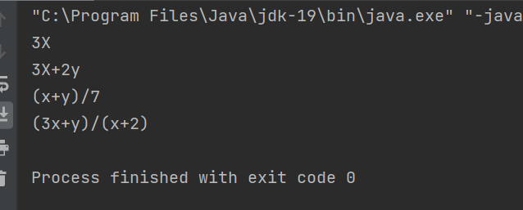

Q2import java.util.Scanner;  
  
public class Main {  
 public static void main(String[] args){  
 Scanner sc = new Scanner(System.in);  
 System.out.println("Enter the marks of 5 Subjects");  
 float s1 = sc.nextInt();  
 float s2 = sc.nextInt();  
 float s3 = sc.nextInt();  
 float s4 = sc.nextInt();  
 float s5 = sc.nextInt();  
  
 float sum= s1+s2+s3+s4+s5;  
 System.out.printf("Yur total marks are = ");  
 System.out.println(sum);  
 float per=(sum/500)\*100;  
 System.out.printf("Your percentage is = ");  
 System.out.println(per);  
 }  
}

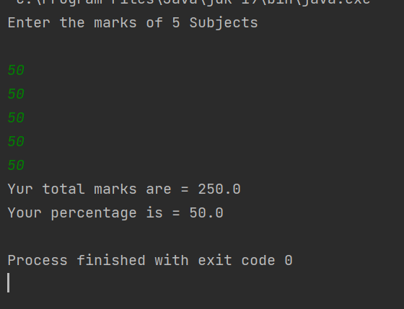

Q3

public class Main {  
 public static void main(String[] args){  
 System.*out*.println("This is my Output");  
 double fun= ((9.5\*4.5)-(2.5\*3))/(45.5-3.5);  
 System.*out*.println(fun);  
  
 System.*out*.println("B PART OF THIS QUESTIOM");  
 int sem = 1+2+3+4+5+6+7+8+9;  
 System.*out*.println(sem);  
 }  
}

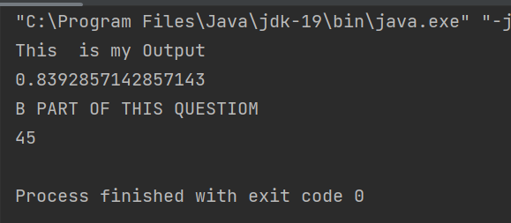

Q4

import java.util.Scanner;  
  
public class Main {  
 public static void main(String[] args) {  
 Scanner sc = new Scanner(System.*in*);  
 System.*out*.println("Enter your Name");  
 String name = sc.nextLine();  
 System.*out*.println("Enter your StudentId");  
 String ID= sc.nextLine();  
 System.*out*.println("Enter your Registered course in sigle line");  
 String cources = sc.nextLine();  
  
 System.*out*.printf("Name ");  
 System.*out*.println(name);  
 System.*out*.printf("ID ");  
 System.*out*.printf("Cources ");  
 System.*out*.println(ID);  
 System.*out*.println(cources);  
 }  
}

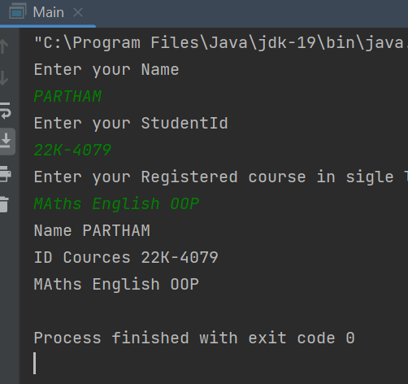

Q5public class Main {  
 public static void main(String[] args)  
 {  
 System.out.println("Hello world!");  
 double res = 4.0\*(1-(1.0/3)+(1.0/5)-(1.0/7)+(1.0/9)-(1.0/11));  
 System.out.println(res);  
 }  
}

